Achievements and Accomplishments for Jan. 2022 through Dec. 2022
Youth Ministry Training/Teen Event Director (Rev. Chase) Report Date: 08/22/2022

Highlights

- 2022 has been a year of transition for the Great Lakes Region Youth and Family Ministry.

- Rev. Kathy Hardwood Long was elected to the Board of Trustees and accepted appointment as YFM Liaison replacing Rev. Wilma Tayolr-Costen.

- Early in the year, March 31, 2022 longtime Teen Event Director, Tyler Pritchard resigned.

- Rev. Chase intends to retire of at the end of the year, Dec. 31, 2022.

- Staff changes initiated an effort to access and evaluate the youth and family ministry services the Great Lake Region provides. It is an opportunity to evolve services to the children, teens, and their families and the ministries in the region The goal is to announce job openings at the Regional Conference, September 26-29, 2002.

- Input from stakeholders was gathered a variety of ways to guide changes to YFM events and services.

- Our first in-person teen event since Fall of 20219 was held in June. Unity of Springfield. IL hosted June Rally as an overnight lock-in.

- Mia Bornstein - Unity Chicago and Jake Bibik – Unity Chicago severed as the Y.O.U. Regional Officers for the 2021/2022 program year. The 2021-2022 Regional Team Mission Statement: " As we come back together we are reminded of the family we have built, and look forward to expanding our community and growing together spiritually" guided them throughout the year.

- Three teens Apryl Hanneman - Unity Chicago, Bastain Short - Unity of Louisville, and Michael McComb - Unity of Louisville were installed into office in August 16, 2022. See Great Lakes Y.O.U. Instagram account for video introductions.

- 2023 is the year for a teen or young adult from each region Great Lakes, Eastern, and Southeast to serve as an International Youth of Unity Officer. No candidates applied to represent the Great Lakes Region.

- The Fall Y.O.U. retreat is set to occur at camp Lutherdale, Oct. 28-30

- A Fall Uniteen retreat is being planned, tentatively at Connect Christian Camp, Nov. 11-13

- Virtual Uniteen and Y.O.U. lessons were held over Zoom throughout 2022.

- Training webinars, videos and collaborative zoom sessions were held throughout 2022. Content and format were driven by the result of a survey.

- More ministries began to offer in-person programs for youth and families.

- The YFM Training Director became available for on-site training events in 2022, however none occurred.

- Ministering with Families, a monthly collaborative training session, held on zoom began Feb. 2022. Guidance, resources, and first-hand experience in partnering with parents/families is aiding ministeries in reimagining how and what services they offer youth and their families.

- Conducted a YFM Survey:
- Results used to guide the services provided.
- Common issues: reaching youth and their families and staffing & recruiting volunteers.
- Training or discussion topics
  - Innovations in YFM - what others are doing
  - Ministering to Families
  - Launching/Relaunching a YFM
- Preferred way of receiving training is on-line.
- There is not sufficient support for an overnight training event this year.
- Email still a preferred method of communication.
- Connecting and networking with colleagues is desired.

2022 Youth and Family Ministry Stats

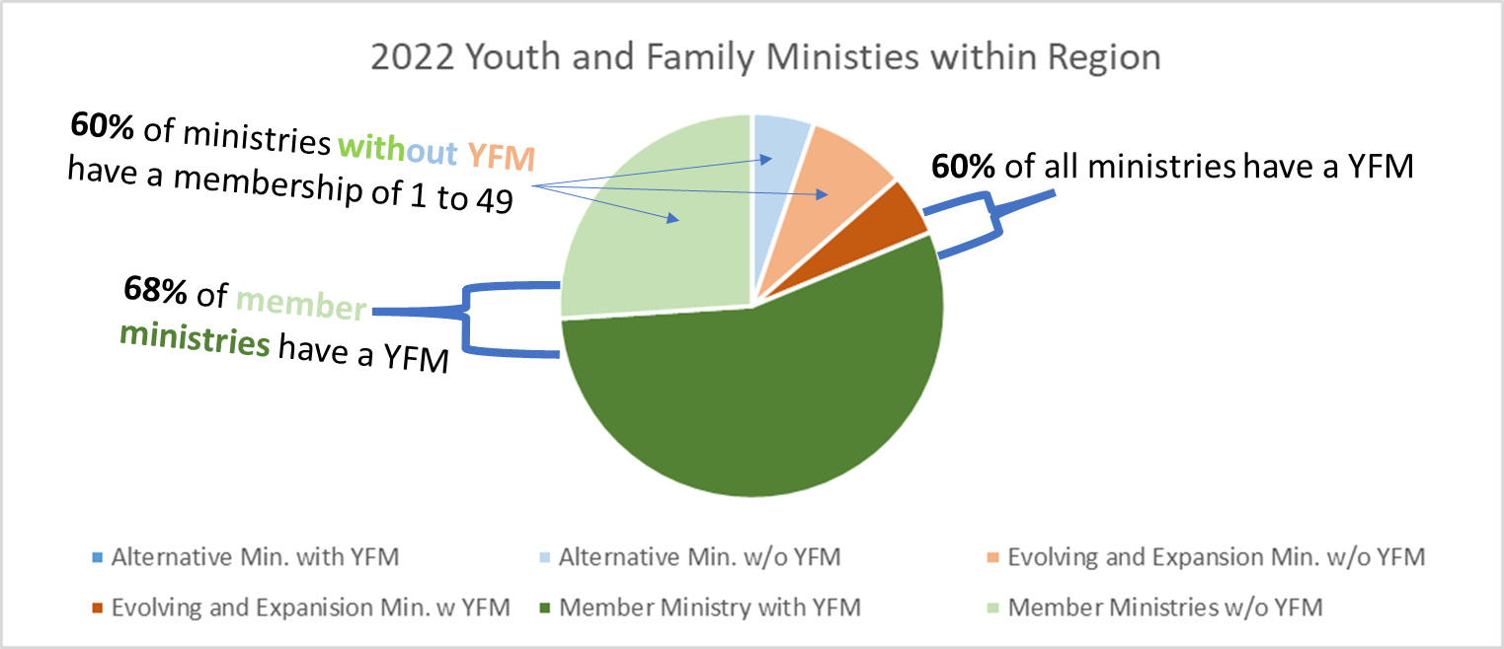

Near 68% of member ministries have a youth program. Member Ministries are represented by the light and darker green on the chart. At least 36% of Member Ministries have a Teen Ministry ( ages 11 to 18). About 38% (5 out of 13) of Expansion Ministries have a youth program. These ministries are represented by the light and darker orange on the chart.

Per the data there are 4 less youth ministries (58 in 2022, 62 in 2021, 58 in 2020). 60% of all ministry types (alternative, evolving and expansion, and member) have a youth and family ministry. Shown in dark green plus dark orange on chart. The average number of youth served on a Sunday across the region is 9% of the number of adults served. Youth attendance dropped to about 46% of 2021 average youth attendance. (Adult in-person attendance dropped to 65% of 2021 average adult attendance.)
66% of centers without YFM have a membership of 1 to 49, 20% of the centers without YFM have a membership 50 to 150. No alternative ministries have a youth and family ministry.
For the ministries reporting the average youth attendance about 85% of them report an average youth attendance of 10 or less. Fewer ministries than last year reported the average youth attendance.

For the ministries reporting average youth attendance the percentage of youth compared to the average adult attendance ranges from 1% to 40%. Just over 16% of the average number of adults in attendance is the average percentage of youth attendance.

The number of YFM teachers and sponsors per ministry with a YFM ranges from 1 to 17 with the average being 3. Ministries size 1- 49 have 1 to 5 teachers, size 50 to 150 have 1 to 11 teachers, size over 151 have 1 to 17 teachers. Near 64% of ministries size of 50 to 150 have 2 or 1 teachers.
In general the fewer adults in attendance the fewer teachers.
The stats for the Great Lakes Region were gathered form annual reports ministries submitted to UWM.
Additional General Services & Activities

- Teen Ministry Events Held
  - Four virtual Lessons for Uniteens, Y.O.U.ers, and their adult leadership
  - June Rally 2022 was held as an overnight lockin at Unity of Springfield, IL
    - Theme: Experiencing the Divine focused on mediation methods
    - 3 ministries participated, 7 teens, 7 adults
  - IYOU 2022
    - 3 ministries from the region participated, 4 teens, 3 adults
  - Connection meetings with Teen Ministry leaders.

- Trainings Developed and Events Held
  - Ministering With Families
    - Ministers, Board Members, youth directors and others meet monthly to learn and share their experience ministering to, with, and through families .
    - Serves about 30 individuals and 30 ministries. Participation grows each month.
    - Meet 8 times in 2022
    - Resource repository created
  - ‘RE’ Youth & Family Ministry!
    - Training consisted of 3 instructional videos paired with a weekly Zoom gathering.
    - Objectives:
      - Become familiar with a proven launch process
      - Learn how to include the four foundational S’s of a solid youth ministry
      - Design an evaluation process to keep connected to youth and their families and to use it to direct the on-going evolution of youth ministry
      - Hear what other ministries are doing

- Transition Activities Conducted
  - Gathered insights and input on youth and family services offered by the region from stakeholders: Youth Directors, Teachers, Uniteen Leaders, YOU Sponsors; Parents, Board Members, Spiritual Leaders, and Ministers
  - Job descriptions created to be posted at conference late September.
  - The need for flexibility, responsiveness, consistency, accountability lead to the creation of a Regional YFM Coordinator position. The Coordinator oversees the implementation of the GLUR Youth and Family Ministries services.
  - A Regional YFM Program Contractor will equip and guide ministries and their staff and volunteers serving families and children birth through 18 years of age through energizing and transformative experiences in-person and online.
  - Regional YFM Program subcontractors will be employed for specific areas of service.
  - The YFM Program Contractor and Subcontractor positions will change and adjust in response to the evolution of services the region provides.

- Events Attended/ Training Received
  - June Rally
  - IYOU
  - Virtual Regional YFM Leadership Team gatherings
  - How to Grow Your Y.O.U.
  - Youth Ministry Leaders’ Summit
  - Webinars offered by International Network of Children’s Ministry
  - South Central Region Innovation Hub Sessions
  - UWM Tech Conference

- Ministry Support:
  - Supported ministries through emails, phone calls and video meetings with Ministers, Board Members, Youth Directors, YOU Sponsors, Uniteen Leaders and Teachers
  - Offered resources related to
    - partnering with parents
    - mental health
    - school shootings
    - back to school
    - recognition ceremonies
    - curriculum
    - holiday materials
    - resuming in-person youth ministries
    - teaching online
    - inclusion

- Routine Activities and Communications
  - Updated Constant Contact lists and points of contact for ministries
  - Marketing efforts for training and retreats
    - Created flyers/registration forms
    - Multiple Constant Contact announcements
    - Facebook post
    - Emails & calls to ministries
  - Phone calls and emails with
    - GLURC YFM Liaison
    - Youth Event Coordinator
    - GLURC Bookkeeper
    - GLURC Treasurer
    - UWM Director of Virtual Experience/YFM Consultant
    - Regional YFM Team Leaders (YFM Consultants)
    - Ministers and YFM Directors new to the Great Lakes Region
  - Connection and follow-up with Great Lakes Region ministries
  - Posted in YFM Facebook groups, Great Lakes Unity Region Facebook page
  - Sent email news/information
  - Input to regional newsletter and website
  - Monthly finance reports to Great Lakes Region Bookkeeper, Treasurer and Board Liaison
  - Monthly activity reports to Board Liaison

- On going activities
  - Building teen leaders - providing opportunities for teens to learn and experience leadership
  - Complete Regional YFM Services transitions by hiring for open Regional YFM Coordinator and YFM Program Contractor jobs and acclimating the new staff.
  - Fall 2022 Y.O.U. Retreat
  - Fall 2022 Unitreat
  - Ministering with Families Sessions
  - Connection and networking opportunities

