Unity Minneapolis EarthCare Events
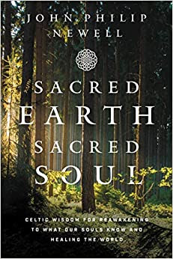
Unity Minneapolis is expanding our EarthCare Ministry -- a group dedicated to the mission of fostering “awareness of our spiritual oneness with the Earth and to promote active care of all creation.”

The Board of Trustees approved the EarthCare Covenant last year and the team got busy. Coming together to share ideas and challenge existing assumptions opens our hearts to each other and to a larger world.

During the week of April 24th, we will begin a 6-week book group series using Sacred Earth Sacred Soul by J. Phillip Newell, focusing on our connection to the earth and to each other. Groups will be both virtual and in person -- and open to all!

Groups via Zoom
Monday | April 25 | 10:30am | Karen Onny, LUT

Monday | April 25 | 7:00 - 8:30pm | Chip Longacre

Tuesday April 26 | 10:30am | Wendy Brown-Baez Wednesday

Wednesday April 27 | 12 Noon | Eden Bodnar

Wednesday April 27 | 7pm | Becky Haaf
-----------------------------------------------------------
IN PERSON in the Fillmore Room:
Thursday April 28 | 10:30a | Rev Toni

Registration is on our website: Registration for Sacred Earth Sacred Soul This series is offered on a Love Offering basis.

On Saturday, April 23rd, our EarthCare team will join with our Youth and our Gardening team for a Spring Cleanup.

On April 29th at 7pm, Buff Grace, Director of Faith Networks for Minnesota Interfaith Power & Light will join us to talk about Finding Encouragement in Action: An alternative to climate change anxiety.

As consequences of climate change have increased across the U.S. in 2021, more and more people have grown aware of the crisis. “Alarmed” is now the largest category in Yale’s Climate Communication polling and three times the number of those who are “Dismissive.” The film, Don’t Look Up, a metaphor for climate denial, is the second most watched on Netflix, ever. But all of this “awareness” seems to have led to more anxiety than action. Buff will share the top effective actions we can take and how to move out of the inertia common to overwhelming issues like climate change. We'll look at a method that helps build a sustaining practice of climate action, at the individual, household, or congregational level.

This month a member of our EarthCare team will be begin coordinating with Hennepin as part of the county’s composting program, in addition to the regular cycling program. More information on all our activities can be found on our Unity Minneapolis website.

You are invited to join our EarthCare FaceBook group as well. “[There is] intelligence inherent in every form, animate or inanimate. It has been discovered that even rocks and all minerals have life… We should be speaking words of truth to everything, not only to mankind but to the mineral, vegetable, and animal kingdoms.” -Charles Filmore in Christian Healing.

