FOR DISTRIBUTION TO ALL REGIONS OF UNITY WORLDWIDE MINISTRIES:
Thank you for sharing the following information with Unity ministries and leaders in your region!
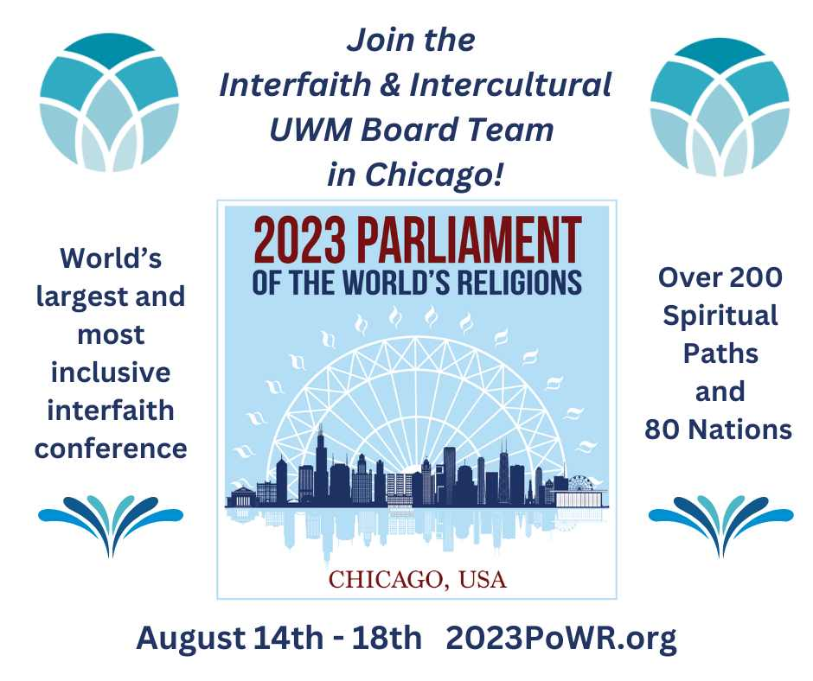
Did you know that Unity founders, Charles & Myrtle Fillmore attended the first ever Parliament of World Religions, held in Chicago in 1893? Unity’s tradition of interfaith continues today, as the Interfaith & Intercultural UWM Board Team has been invited to make a presentation at the Parliament of World Religions 2023. You are invited to attend this powerful IN-PERSON gathering of global consciousness that attracts participants from more than 200 diverse religious, indigenous, and secular beliefs and more than 80 nations. Registrants enjoy access to all the plenary sessions, hundreds of breakout sessions, art & cultural exhibits, performances, a film festival, and countless opportunities to connect with individuals and organizations committed to justice, peace, and sustainability at the world’s largest and most inclusive interfaith conference.
The 2023 Parliament of the World’s Religions will be hosted in McCormick Place Lakeside Center (2301 S King Dr, Chicago, IL 60616) from August 14-18, 2023.
https://parliamentofreligions.org/parliament/2023-chicago/
The session presented by the Interfaith & Intercultural UWM Board Team will take place on Thursday, August 17th, 8-930am.
DISCOVERING the UNIVERSAL WISDOM EXPERIENCE!
with Unity Ministers Jan Chase, Victoria Etchemendy, Tim Lytle, Valerie Mansfield, and Paul John Roach (author of Unity and World Religions)
Connect with a member of the Interfaith & Intercultural UWM Board Team and let us know if you are planning to attend. We will be organizing a time and place to gather during the Parliament, and would love to see you there.
Follow posts in the Unity Interfaith Forum group on Facebook for updates.
Share this information with your interfaith connections.
Attend the Parliament of World Religions 2023!
With gratitude, from the Interfaith & Intercultural UWM Board Team - I am you and you are me!

