Eau Claire EarthCare
The Great Lakes Region celebrates the EarthCare efforts of Unity Eau Claire, Wisconsin.

Unity of Eau Claire's property was developed 25 + years ago, and tending it has been a loving work in progress. It is a beautiful place for weddings and outdoor events.

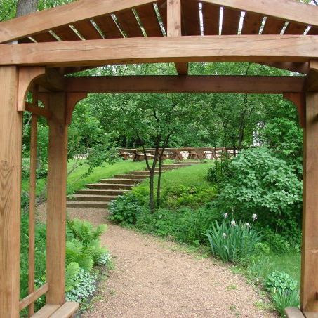

Addressing several problems in the last five plus years meant team work, collaboration, and creative thinking. The results are beautiful and additionally sustain essential ecosystem species like bees.

Their Master gardeners Mari Jackson and Dale Stairwell, and a team of volunteers, have long since stopped counting the many bags of invasives they've pulled, and trailer loads of buckthorn and garlic mustard they've cut and hauled away.

To tackle the erosion problems, they developed a plan and budgeted funds. Members donated native plants! A volunteer labor force created a new berm, swale, and plantings for butterflies, bees, and beauty.

Their next phase includes a new water and rock garden to distribute rain water and slow its absorption to stop the erosion. Unity Eau Claire, you are blessed, and so are we!
Addressing several problems in the last five plus years meant team work, collaboration, and creative thinking. The results are beautiful and additionally sustain essential ecosystem species like bees.
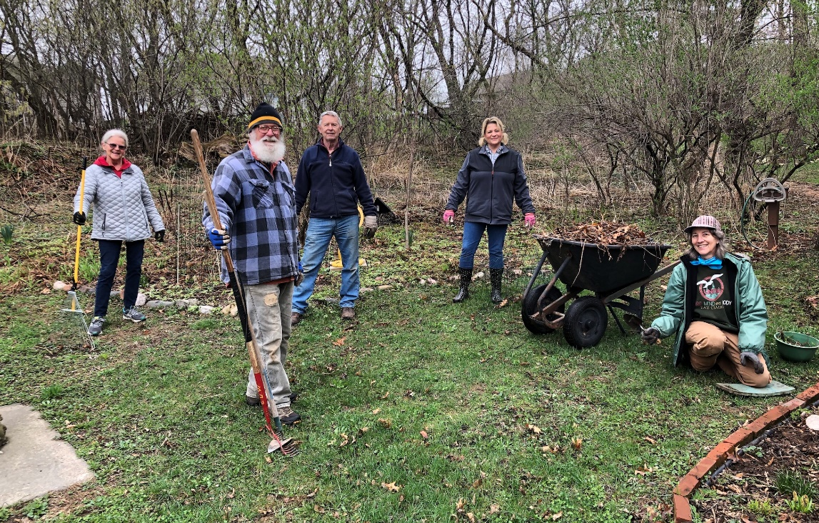
Their Master gardeners Mari Jackson and Dale Stairwell, and a team of volunteers, have long since stopped counting the many bags of invasives they've pulled, and trailer loads of buckthorn and garlic mustard they've cut and hauled away.

To tackle the erosion problems, they developed a plan and budgeted funds. Members donated native plants! A volunteer labor force created a new berm, swale, and plantings for butterflies, bees, and beauty.

Their next phase includes a new water and rock garden to distribute rain water and slow its absorption to stop the erosion. Unity Eau Claire, you are blessed, and so are we!

