EarthCare at Unity of Appleton, WI

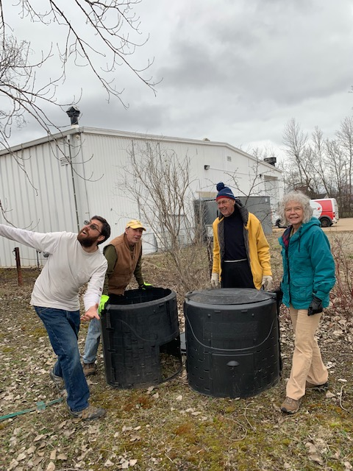
Unity of Appleton, WI, is working with Wild Ones, an organization that preserves native plants and natural landscapes. Members brought in perennials and houseplants for a special sale earning $220 toward a goal of $500 to apply for a matching grant from Wild Ones. Wild Ones visited the Unity of Appleton property offering valuable suggestions including a rain garden for water run-off from their parking lot.
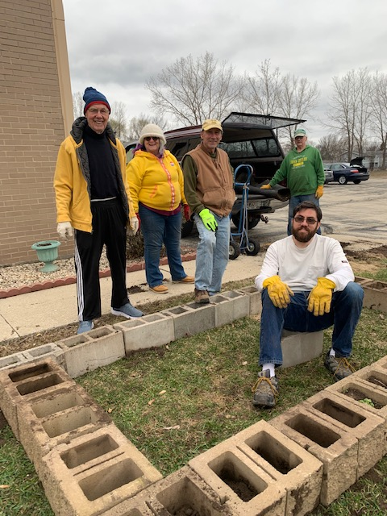
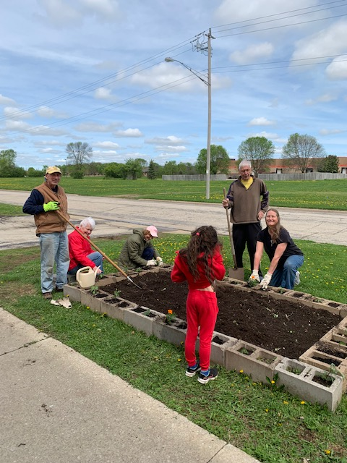
Some old concrete basement blocks were made into a raised bed garden to grow produce–and based on their pictures more delight! Last Sunday, the congregation shared their first lettuce crop with many more vegetables on the way.

